NETWORKING 2
OSI Model:
OSI (Open Systems Interconnection) Model is a conceptual framework created by the International Organization for Standardization (ISO) in 1984 to describe, standardize, and break down network communication into seven distinct functional layers.
- This is just conceptual/theoretical not the used standard.
Application Layer
Data Unit: Data
Definition: Interacts directly with software applications to provide network services to the user.
Protocols: HTTP, HTTPS, FTP, SMTP, DNS, SSH.
Presentation Layer
Data Unit: Data
Definition: Translates, encrypts, decrypts, and compresses data to ensure it is readable by the receiving application.
Protocols: SSL, TLS, SSH, JPEG, GIF.
Session Layer
Data Unit: Data
Definition: Opens, manages, maintains, and terminates communication sessions between applications on different devices.
Protocols: NetBIOS, RPC, PPTP, SOCKS.
Transport Layer
Data Unit: Segments (for TCP) or Datagrams (for UDP)
Definition: Handles host-to-host communication, ensures reliable data delivery, and manages flow control and error checking.
Protocols: TCP, UDP.

Network Layer
Data Unit: Packets
Definition: Determines the best physical path for data routing and handles logical addressing across different networks.
Protocols: IPv4, IPv6, ICMP, IPsec, OSPF, BGP.
Data Link Layer
Data Unit: Frames
Definition: Provides node-to-node data transfer over the physical layer and handles physical MAC addressing and error detection.
Protocols: Ethernet, Wi-Fi (802.11), PPP, ARP, STP.
Physical Layer
Data Unit: Bits
Definition: Transmits and receives raw, unstructured bitstreams over a physical medium like cables or radio waves.
Protocols: Ethernet physical layer (100BASE-T), Bluetooth, USB, DSL.
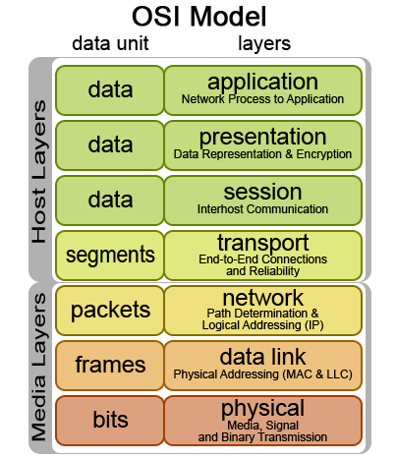
TCP/IP Model
TCP/IP (Transmission Control Protocol/Internet Protocol) is the foundational set of communication rules that allows computers and devices to connect and exchange data across the internet and private networks. hsiuwqduiqwdiuqwdiuqwdiuqwdiuqwdiuwqqwwww
How It Works
IP (Internet Protocol): Acts as the addressing and routing system. It labels each data packet with source and destination IP addresses and steers it across network routers.
TCP (Transmission Control Protocol): Acts as the reliable delivery manager. It breaks messages into packets, tracks their sequence, checks for errors, and asks for lost packets to be resent so the message arrives complete and in order.
The Four Layers of TCP/IP
The TCP/IP Model organizes communication into four functional layers:
Application Layer: Interfaces directly with software applications (web browsers, email clients) using protocols like HTTP, FTP, SMTP, and DNS.
Transport Layer: Manages end-to-end host communication using TCP (reliable) or UDP (fast, connectionless).
Internet Layer: Handles logical addressing and routing via IP and supporting tools like ICMP.
Network Access (Link) Layer: Transmits raw binary data or frames over physical hardware such as Ethernet cables, fiber optics, or Wi-Fi. ghjkllllllllllllllllllllllllllllllllllllllllllllllllllllllllllllllllllllllll
Step-by-Step Encapsulation Process
1. The Application Layer (Raw Data)
What happens: You type "Hello" and hit send. The application formats this message into protocol-specific data (e.g., an HTTP or WebSockets payload).
Current Data Form: nnnnnnnnnnnnnnnnnnnnnnnnnnnnnnnnnnnnnnnnnnnnnnnnnnnnnnn
Data: "Hello"
2. The Transport Layer (Segments)
What happens: The Application layer hands "Hello" down to TCP. TCP splits it if it's large (not needed here) and slaps on a TCP Header. This header contains the source and destination Port Numbers (ensuring it reaches the correct app on the receiver's end) and a tracking sequence number.
Current Data Form: nnnnnnnnnnnnnnnnnnnnnnnnnnnnnnnnnnnnnnnnnnnnnnnnnnnnnnn
TCP Header + Data: "Hello"
3. The Internet Layer (Packets)
What happens: The TCP segment moves down to the IP layer. The IP layer wraps the segment in an IP Header, which acts like a mailing envelope. It stamps the Source IP Address (your device) and Destination IP Address (the receiver's device) on it so routers know how to deliver it across the internet.
Current Data Form: nnnnnnnnnnnnnnnnnnnnnnnnnnnnnnnnnnnnnnnnnnnnnnnnnnnnnnn
IP Header + TCP Header + Data: "Hello"
4. The Network Access Layer (Frames)
What happens: The packet is sent to your local network hardware (Wi-Fi or Ethernet card). The hardware adds a Frame Header containing the Source and Destination MAC Addresses (used to jump from your device to your local router). It also tacks on a Frame Trailer (FCS) at the very end to check for data corruption.
Current Data Form: nnnnnnnnnnnnnnnnnnnnnnnnnnnnnnnnnnnnnnnnnnnnnnnnnnnnnnn
Frame Header + IP Header + TCP Header + Data: "Hello" + Frame Trailer
5. Onto the Physical Wire (Bits)
What happens: The entire frame is converted into physical binary signals (1s and 0s)—pulses of electricity on Ethernet, flashes of light on fiber, or radio waves over Wi-Fi—and shot across the network.
The Destination: Decapsulation
When the receiving device gets the bits, it does this entire process in exact reverse. It peels off the Frame header/trailer, then the IP header, then the TCP header, until nothing is left but the original data: "Hello".
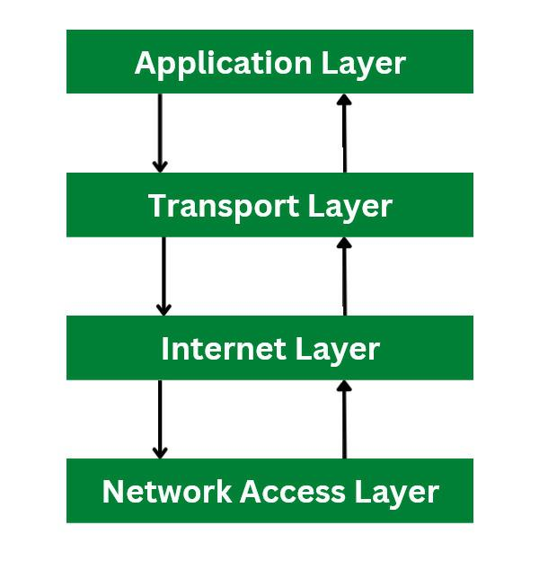

Layer-by-Layer Mapping of TCP/IP vs OSI :
Application Layer (TCP/IP) combines three OSI layers: the Application, Presentation, and Session layers. It handles user interfaces, data formatting, encryption, and session control all at once.
Transport Layer (Both) is identical in function, utilizing TCP for reliable delivery and UDP for fast connectionless data.
Internet Layer (TCP/IP) corresponds to the Network Layer in the OSI model, using IP for logical routing and addressing.
Network Access / Link Layer (TCP/IP) combines the OSI Data Link and Physical layers to manage hardware framing and physical signal transmission.
TCP vs UDP
Transmission Control Protocol (TCP) is a reliable, connection-oriented transport protocol that ensures accurate and ordered data delivery. It uses control mechanisms to guarantee data correctness, which makes it slower but dependable.
- Connection-oriented protocol
- Reliable and ordered data delivery
- Higher overhead but high accuracy
- Uses a three-way handshake to transfer data
Header Size: Variable size between 20 and 60 bytes.
Common Use Cases: Web browsing (HTTP/HTTPS), email (SMTP), file transfers (FTP), and secure shell (SSH).
User Datagram Protocol (UDP) is a fast, connectionless transport protocol that sends data without reliability guarantees. It is efficient for applications where speed is more important than accuracy.
- Connectionless and lightweight
- No guarantee of delivery or order
- Low overhead and high speed
- Connectionless : transfers data without a handshake
- Supports sending data to multiple recipients at once.
Header Size: Fixed, lightweight size of 8 bytes.
Common Use Cases: Real-time applications like Voice over IP (VoIP), live video streaming, online gaming, and DNS lookups.
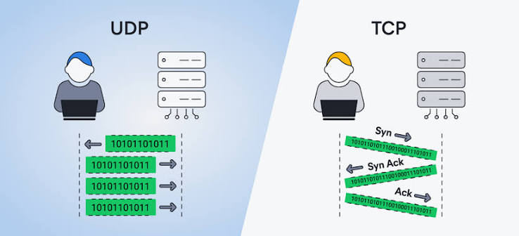
Internet Protocol (IP)
IP address is a unique numerical label assigned to every device connected to a computer network.
Public IP: Assigned by your Internet Service Provider (ISP) to identify your home or business network on the global internet.
Private IP: Used inside a local network (like a home Wi-Fi) to let your router communicate with personal devices.
The Internet Protocol (IP) assigns a unique address to each device, enabling communication over the internet.
- IPv4, the earlier version, uses 32-bit addresses, providing about 4.3 billion unique addresses, which are now nearly exhausted due to the rapid growth of the internet and IoT devices.
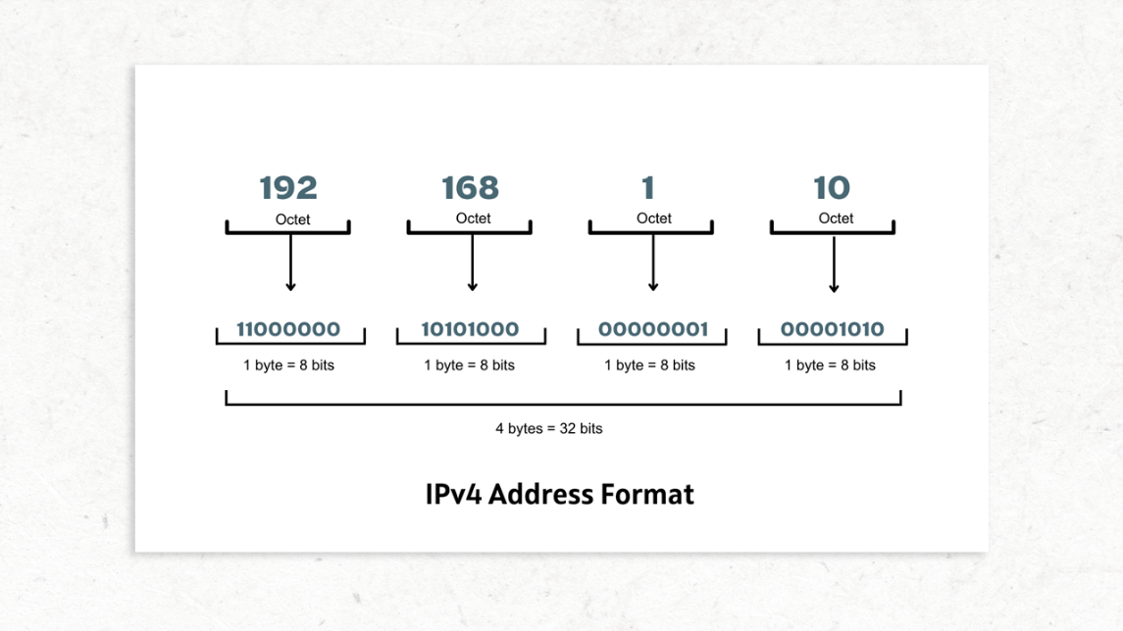
- IPv6, the newer version, uses 128-bit addresses, offering a vastly larger address space to overcome IPv4 exhaustion and support future internet expansion. Provides 340 undecillion unique addresses.

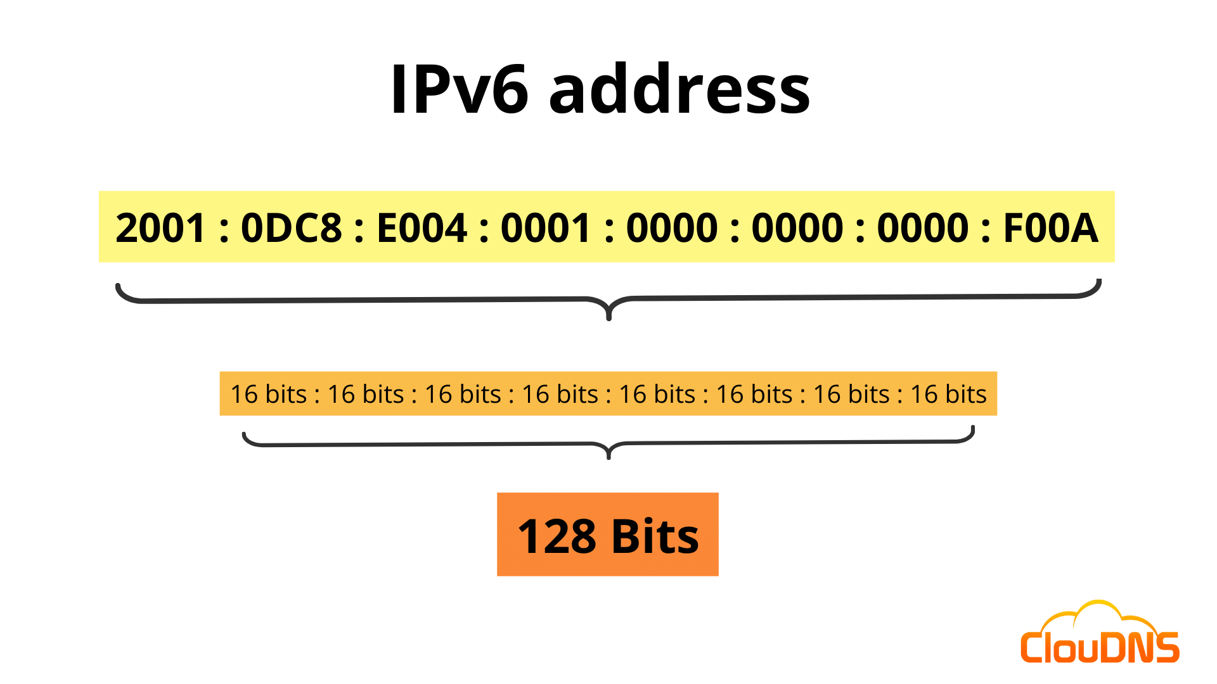
MAC Address
MAC (Media Access Control) address is a 48 bit (12 digit) hexadecimal identifier given to physical device by the manufacturer.
- The first 24 bits (6 digits) are called organizationally unique identifier (OUI) and used to identify the manufacturer/vendor.
- The last 24 bits (6 digits) are called Network Interface Controller (NIC) and used distinguish that specific hardware device from all others produced with the same OUI.
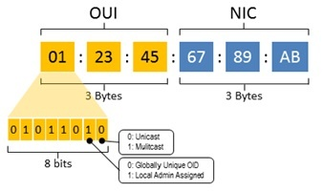
Transmission modes
Transmission modes in networking and telecommunications define how data flows between two connected devices. They are generally categorized into Simplex, Half-Duplex, and Full-Duplex.
1. Simplex (One-Way)
- Direction: Unidirectional — data flows in only one direction.
- Capability: The sender can only send data, and the receiver can only receive it. The receiver cannot reply or send data back.
- Bandwidth: Utilizes the entire channel bandwidth for one-way traffic.
- Examples: Keyboards to monitors, television and radio broadcasting, and computer-to-printer setups.
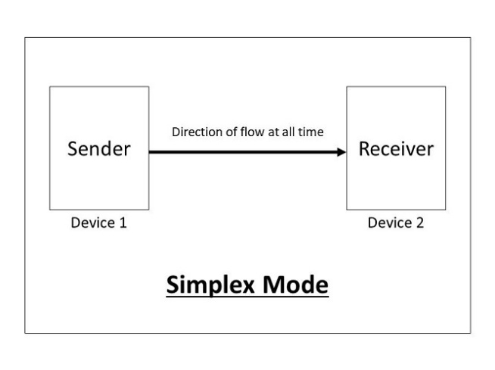
2. Half-Duplex (Two-Way, Turn-Based)
- Direction: Bidirectional, but not simultaneously.
- Capability: Both devices can send and receive data, but only one device can transmit at a time. When one device is sending, the other must wait and listen.
- Mechanism: Requires turn-taking and collision management (such as CSMA/CD in older networks).
- Examples: Walkie-talkies, older legacy Ethernet hubs, and certain two-way emergency radios.
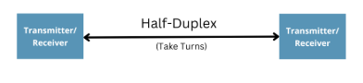
3. Full-Duplex (Two-Way, Simultaneous)
- Direction: Bidirectional and simultaneous.
- Capability: Both connected devices can send and receive data at the exact same time.
- Mechanism: Uses separate channels, frequencies, or dedicated wire pairs (such as separate transmit and receive lines) to prevent collisions.
- Examples: Telephone networks, modern Ethernet switches, cellular communications, and VoIP.


